**Chapter 3**

**Derivatives**

**3.9 Derivatives of Exponential and Logarithmic Functions**

**Section Exercises**

**For the following exercises, find  for each function.**

331. 

Answer: 

333. 

Answer: 

335. 

Answer: 

337. 

Answer: 

339. 

Answer: 

341. 

Answer: 

343. 

Answer: 

345. 

Answer: 

**For the following exercises, use logarithmic differentiation to find **

347. 

Answer: 

349. 

Answer: 

351. 

Answer: 

353. 

Answer: 

355. **[T]** Find the equation of the line that is normal to the graph of at the point where  Graph both the function and the normal line.

Answer:

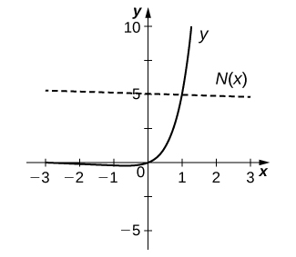



357. Consider the function  for 

1. Determine the points on the graph where the tangent line is horizontal.
2. Determine the points on the graph where  and those where 

Answer: a.  b. 

359. **[T]** The population of Toledo, Ohio, in 2000 was approximately 500,000. Assume the population is increasing at a rate of 5% per year.

1. Write the exponential function that relates the total population as a function of .
2. Use a. to determine the rate at which the population is increasing in  years.
3. Use b. to determine the rate at which the population is increasing in 10 years.

Answer: a. individuals b. individuals per year c.

 individuals per year

361. **[T]** The number of cases of influenza in New York City from the beginning of 1960 to the beginning of 1961 is modeled by the function  where  gives the number of cases (in thousands) and *t* is measured in years, with  corresponding to the beginning of 1960.

1. Show work that evaluates  and Briefly describe what these values indicate about the disease in New York City.
2. Show work that evaluates  and  Briefly describe what these values indicate about the disease in the United States.

Answer: a. At the beginning of 1960 there were 5.3 thousand cases of the disease in New York City. At the beginning of 1963 there were approximately 723 cases of the disease in the United States. b. At the beginning of 1960 the number of cases of the disease was decreasing at rate of  thousand per year; at the beginning of 1963, the number of cases of the disease was decreasing at a rate of  thousand per year.

**For the following exercises, use the population of New York City from 1790 to 1860, given in the following table.**

**New York City Population Over Time**

|  |  |
| --- | --- |
| Years since 1790 | Population |
| 0 | 33,131 |
| 10 | 60,515 |
| 20 | 96,373 |
| 30 | 123,706 |
| 40 | 202,300 |
| 50 | 312,710 |
| 60 | 515,547 |
| 70 | 813,669 |

363. **[T]** Using a computer program or a calculator, fit a growth curve to the data of the form

Answer: 

365. **[T]** Using the exponential best fit for the data, write a table containing the second derivatives evaluated at each year.

Answer:

|  |  |
| --- | --- |
| Years since 1790 |  |
| 0 | 69.25 |
| 10 | 107.5 |
| 20 | 167.0 |
| 30 | 259.4 |
| 40 | 402.8 |
| 50 | 625.5 |
| 60 | 971.4 |
| 70 | 1508.5 |

**Chapter Review Exercises**

***True or False*. Justify the answer with a proof or a counterexample.**

367. Every function has a derivative.

Answer: False.

369. A continuous function has a derivative.

Answer: False

**Use the limit definition of the derivative to exactly evaluate the derivative.**

371. 

Answer: 

**Find the derivatives of the following functions.**

373. 

Answer: 

375. 

Answer: 

377. 

Answer: 

379. 

Answer: 

**Find the following derivatives of various orders.**

381. First derivative of 

Answer: 

383. Second derivative of 

Answer: 

**Find the equation of the tangent line to the following equations at the specified point.**

385. at

Answer: 

**Draw the derivative for the following graphs.**

387.

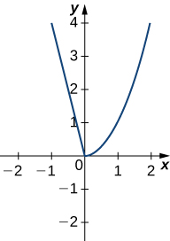

Answer:

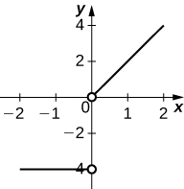

**The following questions concern the water level in Ocean City, New Jersey, in January, which can be approximated by  where *t* is measured in hours after midnight, and the height is measured in feet**.

389. Find What is the physical meaning of this value?

Answer:  At 3 a.m. the tide is decreasing at a rate of 1.514 ft/hr.

**The following questions consider the wind speeds of Hurricane Katrina, which affected New Orleans, Louisiana, in August 2005. The data are displayed in a table.**

**Wind Speeds of Hurricane Katrina**

|  |  |
| --- | --- |
| Hours after Midnight, August 26 | Wind Speed (mph) |
| 1 | 45 |
| 5 | 75 |
| 11 | 100 |
| 29 | 115 |
| 49 | 145 |
| 58 | 175 |
| 73 | 155 |
| 81 | 125 |
| 85 | 95 |
| 107 | 35 |

391. Estimate the derivative of the wind speed at hour 83. What is the physical meaning?

Answer: . The wind speed is decreasing at a rate of 7.5 mph/hr.

This file is copyright 2016, Rice University. All Rights Reserved.